Chapter 6, Solution 31.

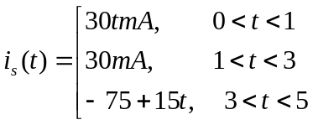

C_{eq} = 4 + 6 = 10μF
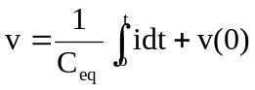

For 0 < t < 1,
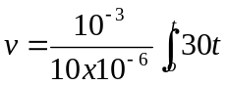dt + 0 = 1.5t² kV

For 1 < t < 3,
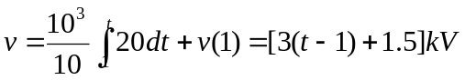
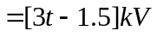

For 3 < t < 5,
